
Year 10A

Mini Test 5

Graphs

Resources allowed: Calculator and 1 x A4 page one side
Name:________________

Marks: / 34

- [5 marks]
Math the following graphs to the type of graph
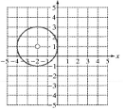 |  | Exponential
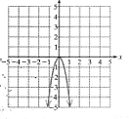 |  | Hyperbola
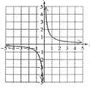 |  | Parabola
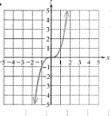 |  | Exponential
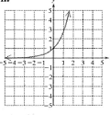 |  | Cubic

- [8 marks]
Graph the following quadratic equations by completing the table of values on the same set of axes and describe the transformation from a) $y=x^{2}$.
- $y=x^{2}$  x -2 -1 0 1 2  y  - $y=x^{2}-3$  x -2 -1 0 1 2  y  Transformation  _____________________  _____________________  _____________________  - $y=2x^{2}$  x -2 -1 0 1 2  y  Transformation  _____________________  _____________________  _____________________ | 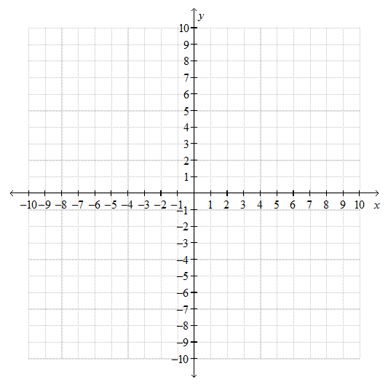

- [6 marks]
For the follow circle equations state the radius and the position of the centre of the circle.

- $x^{2}+y^{2}=3^{2}$ | - ${\left(x-3\right)}^{2}+{\left(y-4\right)}^{2}=16$ | - ${\left(x+5\right)}^{2}+{\left(y-6\right)}^{2}=4$

- [2 marks]
Write the equation of the circle with a radius of 5 and the centre of (2, -3).

- [3 marks]
Graph the hyperbola by completing the table of values and drawing a smooth curve through the points.
$$y=\frac{8}{x}$$  x -3 -2 -1 0 1 2 3  y | 

- [7 marks]
For the following polynomial
$y=x(x+3)(x-5)$
- What are the x intercepts

- Expand $y=x(x+3)(x-5)$

- Sketch the polynomial

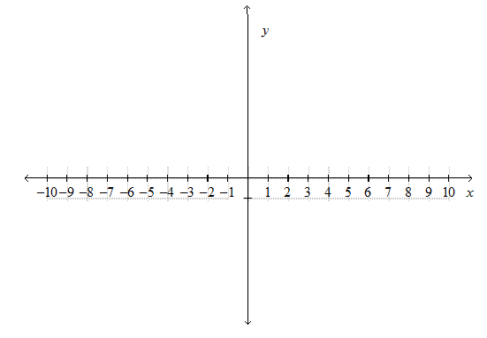

- [3 marks]
A vintage guitar that was bought for $12,000 increases in value by 2% each year.
- Write an exponential function to represent the value of the guitar.

- Estimate the value of the car in 10 years from when it was bought

~End of Test~

